Finance report – 9th January 2025

Finance – RFO
- Payment approval

- Office expenses summary

- Budget summary

- Bank reconciliation – 9th January 2025

Balance as per statement £4,586.75

Less payments to be made £0

Balance as per cashbook £4,586.75

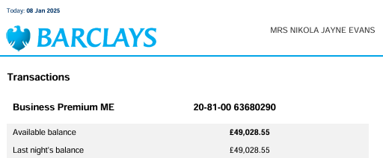

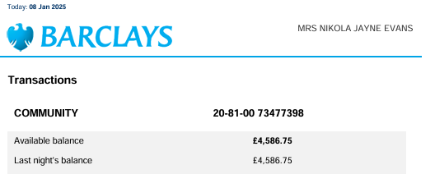
Signed __________________________ Date ________________________ Signed ________________________ Date ________________________

