
Minutes of the full council Meeting held on Thursday 9th April 2026 at 7.00pm at St Thomas and St Andrew Church, Doxey Road, Stafford, ST16 1EQ

Attendees
Cllr D Hughes (Chair) | Cllr R Whyman (Vice Chair) | Cllr S Davenport
Cllr K Allen | Cllr E Tristram | Cllr I Davies
Cllr C Haigh | Cllr C Hughes | Cllr C Shirley
Cllr T Pearce - SBC | Cllr J Rose – SCC | Mrs Nikola Evans – Clerk
MOP - 2
Minutes
1 | Declaration of Interests on agenda items and any dispensations granted
 | None received
2 | Apologies
 | None received
3 | To confirm the minutes from the extraordinary finance meeting on 14th May 2026, are a true record
 | RESOLVED to approve as a true record
4 | To adjourn the meeting to allow public participation (Members of the public are invited to address the Council on any issue over which it has power for up to 5 minutes each, with the item lasting a maximum of 20 minutes).
 | Members from St Tomas and St Andrew’s church and Doxey Meadows Group presented reports on their grant requests.
5 | To receive Stafford Borough Councill report

Cllr T Pearce reported on the following:
- Stafford Town Centre Regeneration
- Victoria Park tree planting initiative
- New local plan consultation
6 | To receive Staffordshire County Council report

Cllr J Rose reported on the following:
- HGV’s traveling through Doxey Village. Reached out to companies, seems to have calmed down for now, will monitor.
- Hedge on corner of Reed Drive, Submitted FOI for report on near misses, requested the gateway team look into finally sorting it out. Cllr Rose remains hopeful.
- Greensome Lane gully has been jet washed several times, however still unable to locate the issue. Needs further investigating, Cllr Rose will monitor.

Meeting closed to the public
7 | To discuss new Planning applications  - 26/42062/REM - Burleyfields (phase 5), Land west of Martin Drive, Castlefields. Stafford - 285 dwellings
 | No objections
8 | Finance
8.1 | Payments for approval  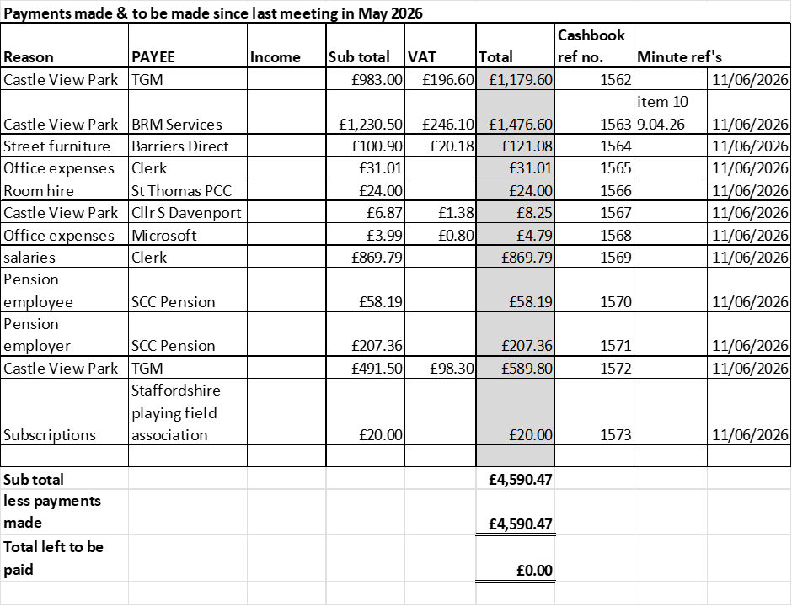  RESOLVED to approve all payments
8.2 | Budget Summary
 | RESOLVED to approve
8.3 | Bank reconciliation
 | RESOLVED to approve
8.4 | To consider grant application request from Doxey Church. Cost towards funding a mini bus for 2026 family excursion.
 | RESOLVED all in favour to approve
8.5 | To consider grant application request from Doxey Meadows Group. Cost to fund an inclusive picnic bench for community gardens.
 | RESOLVED not to award a grant on this occasion. The Council has a limited Community Grant budget of £1,000 for the current financial year, and this application exceeded the total amount available within the grant scheme.
9 | Reports  - Councillors – Information only  - Cllr Tristram reported on the Gateway community forum. Requested the parish council put forward a project the forum would support, suggested area on corner of Reed Drive which is marked as Wicketgate and the former cricket pitch. Another meeting in early July.  - Clerk – To receive update regarding going projects and agree further actions  - Lawn mower – RESOLVED to offer a selling price of £100 to the Universal Club. Clerk to organise.  - Weeding at Castle view Park, particularly on the wetpour around the slide. Clerk to action
10 | Items for next agenda

Proposed next agenda items
- To discuss and consider a petition and drumming up residential support for the transfer of the Rugby Pitch – Cllr Tristram
- To discuss and consider options for a community bus – Cllr Tristram
11 | To agree date of next meeting, at St Andrews and St Thomas Church, from 7pm unless stated otherwise.  - 9th July 2026
 | RESOLVED to approve
12 | Future meeting dates:  - 10th September 2026  - 8th October 2026  - 12th November 2026  - 14th January 2027  - 11th February 2027  - 11th March 2027  - 8th April 2027  - 13th May 2027 – Annual public meeting – 6:30pm  - 13th May 2027 – Annual Parish council meeting – 7:00pm
 | RESOLVED to approve
13 | Meeting Closed
 | 20:25

For the purpose of these minutes SCC refers to Staffordshire County Council, SBC refers to Stafford Borough Council and MOP refers to member of the public.

