
Minutes of the Extraordinary Finance Meeting held on Thursday 15th January 2026 at 7.00pm at St Thomas and St Andrew Church, Doxey Road, Stafford, ST16 1EQ

Attendees
Cllr D Hughes (Chair) | Cllr R Whyman (Vice Chair) | Cllr S Davenport
Cllr K Allen | Cllr E Tristram | Cllr I Davies
Cllr C Haigh | Cllr C Hughes | Cllr C Shirley
Cllr T Pearce - SBC | Cllr J Rose – SCC | Mrs Nikola Evans – Clerk
MOP -
Minutes
1 | Declaration of Interests on agenda items and any dispensations granted
 | None received
2 | Apologies
 | Cllr C Shirley & Cllr I Davies - Accepted
3 | To confirm the minutes from the meeting which took place on 13th November 2025, are a true record
 | Approved as a true record of events by all that attended
4 | Finance
4.1 | Payments for approval
 | All payments APPROVED
4.2 | Budget Summary
 | APPROVED
4.3 | Bank reconciliation
 | APPROVED
4.4 | To approve budget for 2026-27

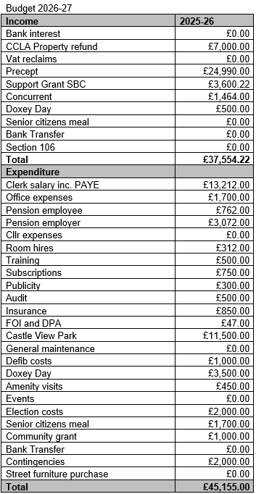

APPROVED
4.5 | To approve precept request for 2026-27
 | RESOLVED to request £24,990 for 2026-27 precept, clerk to action
4.6 | To consider increasing earmarked funds for uncontested elections in 2027 to £10,000, budgeting £2,000 out of 2026-27 and 2027-28 to cover. Due to potential local government reorganisation plans.
 | APPROVED
4.7 | To retrospectively approve expenses of a mobile phone, cost will be split 4 ways with clerk’s other parish councils. Purpose to comply with new Assertion 10 criteria.
 | APPROVED
4.8 | To retrospectively approve expenditure on repairs for the bus shelter on Greensome Lane @ £118 + VAT. Agreed as per scheme of delegation.
 | APPROVED
4.9 | To consider and approve request to subscribe to a PO Box, cost to be split 4 ways with clerk’s other parish councils. Purpose to comply with new Assertion 10 criteria.
 | APPROVED
5 | To confirm date of next full council meeting, at St Andrews and St Thomas Church, from 7pm unless stated otherwise.  - 12th February 2026
 | APPROVED
6 | Meeting Closed
 | 19:15

For the purpose of these minutes SCC refers to Staffordshire County Council, SBC refers to Stafford Borough Council and MOP refers to member of the public.

