
Minutes of the full council Meeting held on Thursday 9th April 2026 at 7.00pm at St Thomas and St Andrew Church, Doxey Road, Stafford, ST16 1EQ

Attendees
Cllr D Hughes (Chair) | Cllr R Whyman (Vice Chair) | Cllr S Davenport
Cllr K Allen | Cllr E Tristram | Cllr I Davies
Cllr C Haigh | Cllr C Hughes | Cllr C Shirley
Cllr T Pearce - SBC | Cllr J Rose – SCC | Mrs Nikola Evans – Clerk
MOP - 0 | Robert Pritchard – SPCA CEO
Minutes
1 | Declaration of Interests on agenda items and any dispensations granted
 | None received
2 | Apologies
 | Cllr C Shirley - Accepted
3 | To confirm the minutes from the extraordinary finance meeting on 12th March 2026, are a true record
 | RESOLVED to approve as a true record
4 | To adjourn the meeting to allow public participation (Members of the public are invited to address the Council on any issue over which it has power for up to 5 minutes each, with the item lasting a maximum of 20 minutes).
 | The council were joined by Robert Pritchard CEO of Staffordshire Parish Council Association (SPCA) to report on the Governance Review currently taking place.
5 | To receive Stafford Borough Councill report
 | Cllr T Pearce gave a report on Stafford Borough’s plans
6 | To receive Staffordshire County Council report
 | Cllr J Rose reported on various highways issues withing the parish

Meeting closed to the public
7 | To discuss new Planning applications
 | None
8 | Finance
8.1 | Payments for approval

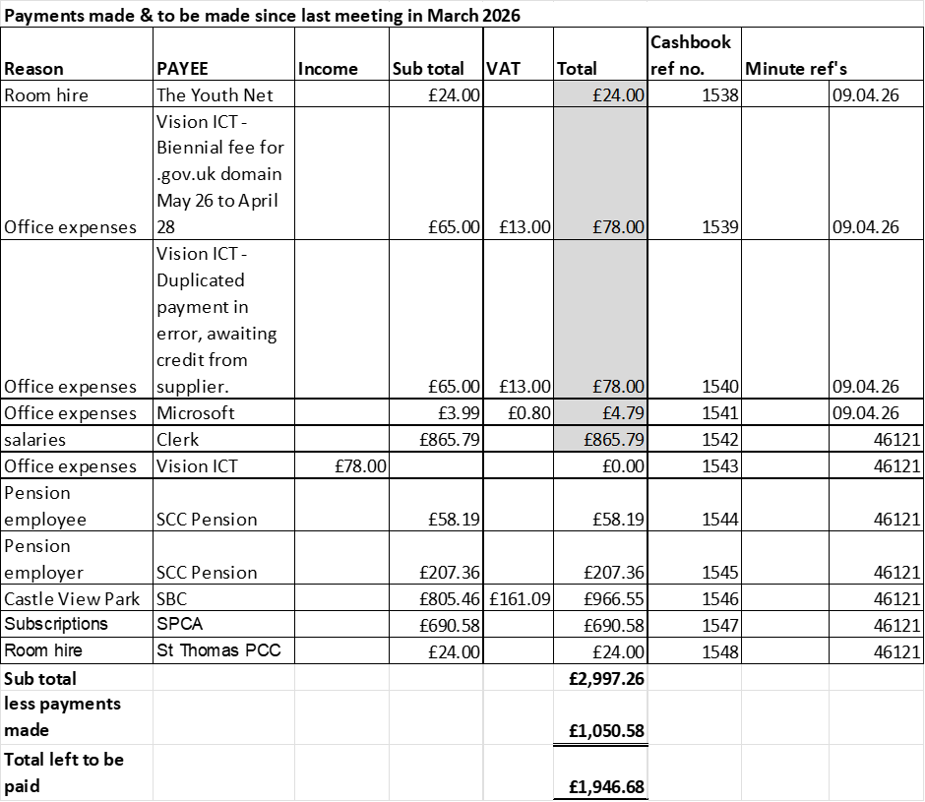

RESOLVED to approve payments
8.2 | Budget Summary
 | RESOLVED to approve payments
8.3 | Bank reconciliation
 | RESOLVED to approve payments
9 | To discuss and consider quotations for replacing wet pour on swings and bar frame
 | RESOLVED to accept quotation from Play Sources Ltd for the complete overlay of safety surfacing to Swings and bar frame. @ £12,926 + VAT, also RESOLVED to withdraw funds to cover from CCLA Investment fund.
10 | To discuss and consider relaying more aggregate to reinstate surfaces on the BMX track and footpaths.
 | RESOLVED to accept quotation from BRM Services @ £1230.50 + VAT also RESOLVED to withdraw funds to cover from CCLA Investment fund.
11 | To discuss and consider repainting containers to cover up graffiti.
 | Included in quotation above from BRM Services. RESOLVED to accept
12 | To discuss and consider arrangements for Doxey Village Fun Day
 | RESOLVED to delegate to the clerk to make the necessary arrangements.
13 | Councillors’ & Clerks reports – Information only
 | Community Governance Review update given by the clerk. Hoping to have more information once the CGR committee has met on 20th April 2026.
14 | Items for next agenda
 | Community Governance Review update - Clerk
15 | To agree date of next meeting, at St Andrews and St Thomas Church, from 7pm unless stated otherwise.  - 14th May 2026 – Annual Public Meeting from 6:30pm  - 14th May 2026 – Annual Parish Council Meeting from 7pm
 | RESOLVED to approve
16 | Future meeting dates:  - 11th June 2026  - 9th July 2026  - 10th September 2026  - 8th October 2026  - 12th November 2026  - 10th December 2026 - TBC
 | RESOLVED to approve
17 | Meeting Closed
 | 20:25

For the purpose of these minutes SCC refers to Staffordshire County Council, SBC refers to Stafford Borough Council and MOP refers to member of the public.

