
Minutes of the full council Meeting held on Thursday 12th March 2026 at 7.00pm at St Thomas and St Andrew Church, Doxey Road, Stafford, ST16 1EQ

Attendees
Cllr D Hughes (Chair) | Cllr R Whyman (Vice Chair) | Cllr S Davenport
Cllr K Allen | Cllr E Tristram | Cllr I Davies
Cllr C Haigh | Cllr C Hughes | Cllr C Shirley
Cllr T Pearce - SBC | Cllr J Rose – SCC | Mrs Nikola Evans – Clerk
MOP - 1
Minutes
1 | Declaration of Interests on agenda items and any dispensations granted
 | None received
2 | Apologies
 | Cllr R Whyman – Sickness, apology accepted
3 | To confirm the minutes from the extraordinary finance meeting on 12th February 2026, are a true record
 | RESOLVED to approve as a true record
4 | To adjourn the meeting to allow public participation (Members of the public are invited to address the Council on any issue over which it has power for up to 5 minutes each, with the item lasting a maximum of 20 minutes).
 | Representative from MP’s office attended and gave a report
5 | To receive Stafford Borough Councill report

Cllr T Pearce attended and reported on the following subject:
- Debris from HGV’s traveling down Doxey Road
- Town centre regeneration
- Local plan
- Doxey Meadows
6 | To receive Staffordshire County Council report

Cllr J Rose attended and reported on the following:
- Saint Gobain consultation
- HGV issues on Doxey Road, including light and noise pollution.
- Blocked gullies – corner of Greensome Lane and Doxey Rd – (4488057)
- Rugby pitch asset transfer
- Speed and pedestrian survey – deadline 1st May

Meeting closed to the public
7 | To discuss new Planning applications
 | None
8 | Finance
8.1 | Payments for approval

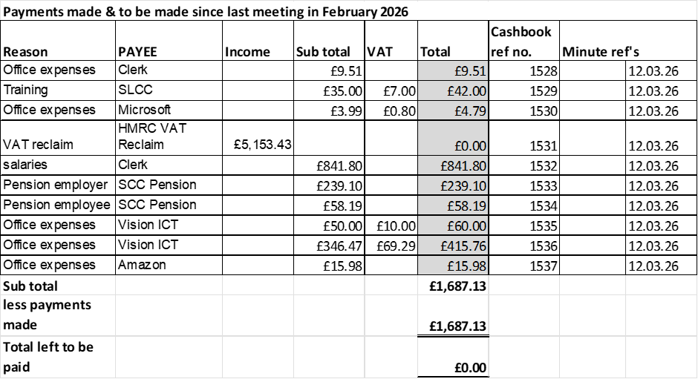

RESOLVED to approve payments
8.2 | Budget Summary
 | RESOLVED to approve
8.3 | Bank reconciliation
 | RESOLVED to approve
9 | To discuss and consider seeking advice from a solicitor to determine whether the Parish Council’s investment fund for the play area can lawfully be transferred to a trust, and to agree any associated actions.
 | RESOLVED to proceed, all in favour, clerk to action
10 | To seek advice from a solicitor on whether the play area can be transferred to a trust for ongoing maintenance and management.
 | RESOLVED to proceed, all in favour, clerk to action
11 | To consider, in the event that the Parish Council is dissolved following the Community Governance Review, whether the funds should be transferred out of the investment fund and used to redevelop the play area prior to the dissolution of Doxey Parish Council.
 | Defer to next meeting
12 | Councillors’ & Clerks reports – Information only
 | None
13 | Items for next agenda
- Arrangements for Doxey Village Fun Day
- Arrangements for Xmas Meal
- General maintenance for castle view park.
14 | To agree date of next meeting, at St Andrews and St Thomas Church, from 7pm unless stated otherwise.  - 9th April 2026
 | RESOLVED to Approve
15 | Future meeting dates:  - 14th May 2026 – Annual Public Meeting from 6:30pm  - 14th May 2026 – Annual Parish Council Meeting from 7pm  - 11th June 2026  - 9th July 2026  - 10th September 2026  - 8th October 2026  - 12th November 2026
 | RESOLVED to Approve
16 | Meeting Closed
 | 20:20

For the purpose of these minutes SCC refers to Staffordshire County Council, SBC refers to Stafford Borough Council and MOP refers to member of the public.

