
Minutes of the parish council meeting held on Thursday 13th November 2025 at 7.00pm at St Thomas and St Andrew Church, Doxey Road, Stafford, ST16 1EQ

Attendees
Cllr D Hughes (Chair) | Cllr R Whyman (Vice Chair) | Cllr S Davenport
Cllr K Allen | Cllr E Tristram | Cllr I Davies
Cllr C Haigh | Cllr C Hughes | Cllr C Shirley
Cllr T Pearce - SBC | Cllr J Rose – SCC | Mrs Nikola Evans – Clerk
MOP -
Minutes
1 | Declaration of Interests on agenda items
 | Cllr Shirley & Cllr Allen declared a personal interest in Item 8 & 9
1.1 | Dispensations granted
 | Granted to stay during discussions, but not to take part.
2 | Apologies
 | Cllr Whyman – No apology received
3 | To confirm the minutes from the meeting which took place on 9th October 2025, are a true record
 | Approved as a true record
4 | To adjourn the meeting to allow public participation (Members of the public are invited to address the Council on any issue over which it has power for up to 5 minutes each, with the item lasting a maximum of 20 minutes).
 | None
4.1 | To receive Stafford Borough Councill report
Cllr T Pearce reported in the following:
- Town centre regeneration, joint project with SCC. Consultation on 26th November 3pm – 7pm @ SCC offices
- Local government reorganisation
- Sustainability and what Cllr Pearce does apart from SBC duties
- Local nature recovery project
4.2 | To receive Staffordshire County Council report
 | None
Meeting closed to the public
5 | To receive clerks report for an update on actions from previous meetings
Rugby Pitch
The matter is scheduled to be discussed at the Sub Property Committee meeting on 19 November. I will be able to provide you with an update following that meeting, once feedback has been received. Cllr Hayley Coles - Cabinet Member Culture & Communities
Play area
Works have started on new surfaces and maintenance on play equipment. On Wednesday 12th they will be back to finish the remedial works and raise the fencing. Rubber works will take place on 13th-14th weather permitting. MUGA – will be scheduled in for works to start in the new year after February. Date TBA
Noticeboard
Order placed – 35-42 working day lead time. Exp install date of sometime in December, may roll over into January because of Christmas holidays.
6 | To discuss new Planning applications
6.1 | 25/41077/REM at Land West of Stafford Martin Drive Castlefields - described as Reserved Matters application (Layout, Scale, Internal Access, Appearance and Landscaping) to hybrid planning permission 17/27731/FUL (granted on 22nd May 2019) for the erection of a Neighbourhood Centre and associated infrastructure within Phase 2.
 | No objections
7 | Finance – RFO
7.1 | Payments for approval - APPROVED
 | 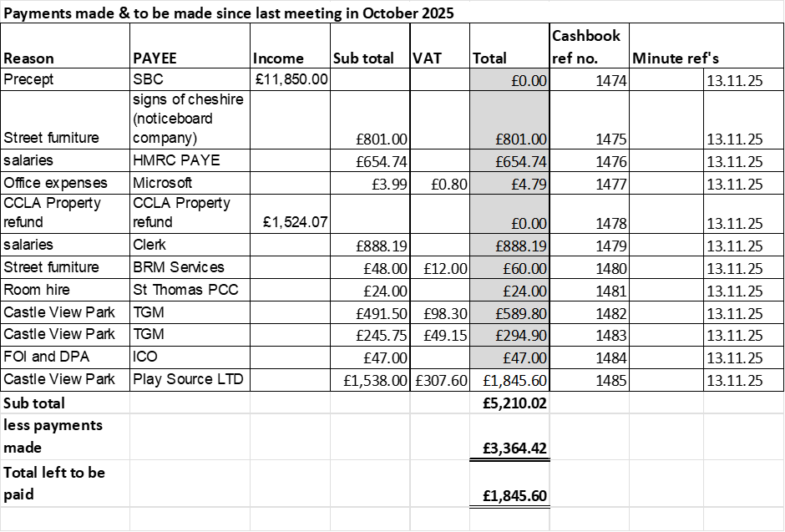
7.2 | Budget Summary
 | APPROVED
7.3 | Bank reconciliation
 | APPROVED
7.4 | Approval to purchase updated version of Charles Arnold-Baker, 14th Edition @ £144.
 | APPROVED
8 | To consider grant application from Doxey Meadows Group – Outdoor Gym Equipment
 | Rejected – Budget allocation for 2025-26 has been allocated, advised to re-submit application in April for consideration out of 2026/27 allocation.
9 | To consider grant application from Doxey Meadows Group – Picnic Benches
 | Rejected – Budget allocation for 2025-26 has been allocated, advised to re-submit application in April for consideration out of 2026/27 allocation.
10 | To consider civic amenity visits for 2026
 | APPROVED – 1-hour, single location for 3 times a year during 2026 @ £122 + VAT per hour
11 | Councillor information
 | Cllr Shirley reported on Neighbourhood Watch scheme and encouraged other councillors to join.
12 | Items for next agenda
 | None suggested
13 | To agree date of next meeting, at St Andrews and St Thomas Church, from 7pm unless stated otherwise.  - 8th January 2026
 | APPROVED
14 | Future meeting dates:  - 12th February 2026  - 12th March 2026  - 9th April 2026  - 14th May 2026 – Annual Public Meeting from 6:30pm  - 14th May 2026 – Annual Parish Council Meeting from 7pm | - 11th June 2026  - 9th July 2026  - 10th September 2026  - 8th October 2026  - 12th November 2026
 | APPROVED
15 | Meeting Closed
 | 19:44

For the purpose of these minutes SCC refers to Staffordshire County Council, SBC refers to Stafford Borough Council and MOP refers to member of the public.

