
Minutes of the parish council meeting held on Thursday 9th October 2025 at 7.00pm at St Thomas and St Andrew Church, Doxey Road, Stafford, ST16 1EQ

Attendees
Cllr D Hughes (Chair) | Cllr R Whyman (Vice Chair) | Cllr S Davenport
Cllr K Allen | Cllr E Tristram | Cllr I Davies
Cllr C Haigh | Cllr C Hughes | Cllr C Shirley
Cllr T Pearce - SBC | Cllr J Rose – SCC | Mrs Nikola Evans – Clerk
MOP - 1
Minutes
1 | Declaration of Interests on agenda items
 | Item 10 – Cllr Shirley and Cllr Allen
1.1 | Dispensations granted
 | Granted to stay – no vote
2 | Apologies
 | Cllr Whyman – Sick - Accepted
3 | To confirm the minutes from the meeting which took place on 11th September 2025, are a true record
 | Approved as a true record from all that attended
4 | To adjourn the meeting to allow public participation (Members of the public are invited to address the Council on any issue over which it has power for up to 5 minutes each, with the item lasting a maximum of 20 minutes).
 | MOP – reported on Doxey Meadows and proposed new allotments
4.1 | To receive Stafford Borough Councill report

Cllr Pearce reported on the following:
- Local Government Reorganisation
- Decontamination of two site, Old Factory and Chevron Garage
- Commercial interest has been expressed for the old Wilko site
- Revised allocation policy by SBC housing tightened up criteria
4.2 | To receive Staffordshire County Council report
 | None
4.3 | To receive Local PCSO reports
 | None

Meeting closed to the public
5 | To receive update on actions from previous meetings
 | none
5.1 | New noticeboards, to consider quotations received
 | RESOLVED: replace noticeboard outside Doxey House with a larger one and remove one from New Testament Church of God. Approved quotation from The Parish Noticeboard Company. Clerk to action.
6 | To discuss new Planning applications
 | None to discuss
7 | Finance – RFO
7.1 | Payments for approval

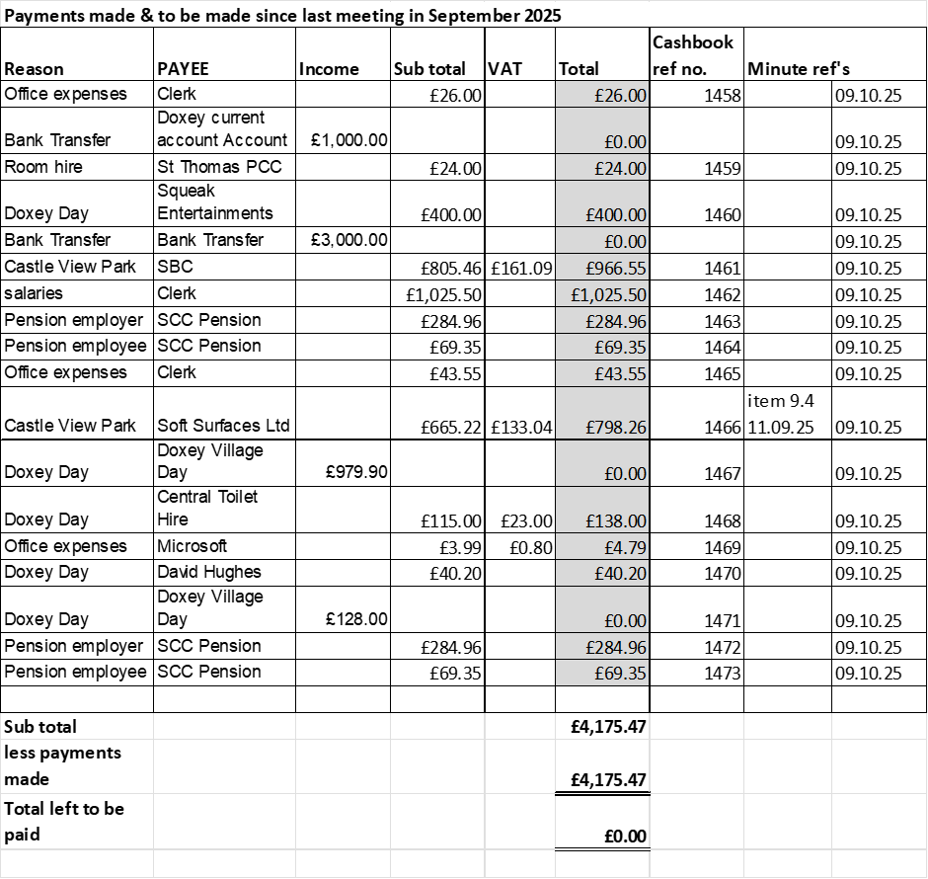

APPROVED
7.2 | Budget Summary
 | APPROVED
7.3 | Bank reconciliation
 | APPROVED
7.4 | To consider and agree draft budget for 2026-27
 | APPROVED
8 | To discuss and approve essential maintenance repairs to Castle View Park.
- Equipment – 3 quotations accepted from Play Source Ltd, clerk to action
- 2026 inspections – RESOLVED: Continue with Hags Uk Ltd
9 | To consider grant application from New Testament Church of God
 | REJECTED: Budget allocation has been used for 2025-26, organisation does not meet the criteria sufficiently to justify the expenditure.
10 | To consider grant application from Doxey Meadows Group
 | DEFERRED
11 | To discuss any new highways, footpaths and village maintenance issues.
- Greensome Lane footpath
- Reed Drive Corner hedge
- Motorbikes on Rugby Pitch

Clerk to report
12 | Councillor information and items for the next agenda
 | None
13 | Items for next agenda
 | Precept 2026-27
14 | To agree date of next meeting, at St Andrews and St Thomas Church, from 7pm unless stated otherwise.  - 13th November 2025
14.1 | Future meeting dates:  - 11th December 2025 – TBC - CANCELLED  - 8th January 2026  - 12th February 2026  - 12th March 2026  - 9th April 2026  - 14th May 2026 – Annual Public Meeting from 6:30pm  - 14th May 2026 – Annual Parish Council Meeting from 7pm  - 11th June 2026  - 9th July 2026  - 10th September 2026  - 8th October 2026  - 12th November 2026  - 10th December 2026 - TBC
15 | Meeting Closed
 | 20:15

