
Minutes of the parish council meeting held on
Thursday 11th September 2025 at 7.00pm
at St Thomas and St Andrew Church,
Doxey Road, Stafford, ST16 1EQ
Attendees
Cllr R Whyman (Vice Chairman) Cllr D Hughes (Chairman) Cllr I Davies
Cllr C Haigh Cllr S Davenport Cllr C Hughes
Cllr C Shirley Cllr E Tristram (arrived at 19:09pm)
Nikola Evans – Clerk Cllr T Pearce – SBC 1 x MOP
1 | Declaration of Interests on agenda items and dispensations granted
 | None received
2 | Apologies  - Cllr K Allen – Other Commitments - ACCEPTED
3 | Minutes of the last meeting – 10th July 2025
 | Approved as a true record
4 | To adjourn the meeting to allow public participation
 | Representative from the church attended and thanked the parish council for the donation towards this year’s coach trip.
5 | To receive Stafford Borough Councill and Staffordshire County Council reports
 | Stafford Borough Councillor T Pearce attended and gave a report, no attendance from County Council

Meeting closed to the public
6 | To receive an update on actions from previous minutes
 | New noticeboards, awaiting quotations, no further information.
7 | To discuss new Planning applications
 | None to discuss
8 | Finance – RFO  Payment Approval - APPROVED  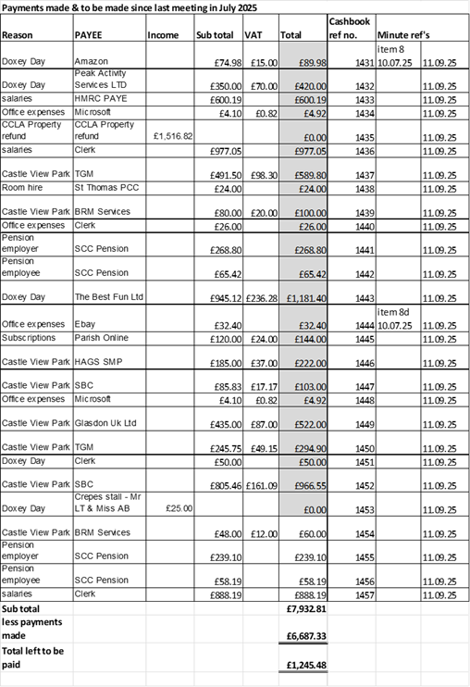
8.1 | Budget summary - APPROVED
8.2 | Bank reconciliation - APPROVED
8.3 | Completion of 2024-25 external audit report - ACCEPTED
9 | To discuss essential maintenance repairs to Castle View Park.
9.1 | Approve cost of new bin to replace damaged one. Glasdon UK Ltd @ £522 inc. VAT – APPROVED, clerk to action
9.2 | Equipment – Awaiting Quotes
9.3 | 2026 inspections – Awaiting Quotes
9.4 | MUGA – clean and reline. – Quotation APPROVED – Soft Surfaces Ltd, clerk to action
10 | To discuss any new highways, footpaths and village maintenance issues.

Greensome lane footpath, clerk to report

Bus shelter repair, clerk to action
11 | Councillor information and items for the next agenda  Update received about Doxey Day 2025
11.1 | Items for next agenda  Draft Budget for 2026/27  General Reserves  Precept for 2026/27
12 | To agree date of next meeting  9th October 2025
12.1 | Future meeting dates:  13th November 2025  11th December 2025 - TBC
13 | Meeting Closed
 | 20:00

